- SCOPE

The specific purpose for this Work Instruction is to provide details on the basic functionalities of the CSSP water quality input tool. For step by step instructions on data entry using the input tool, view the ‘Data entry using the CSSP input tool’ WI (005_W8)’.

- REFERENCES

WI: Creating sampling plan with CSSP Webtools.
WI: Data entry using the CSSP input tool (005_W8)

- PROCEDURE

3.1 Install the CSSP water quality input tool using the setup.exe on the shared drive (Shellfish\CSSP_Code\CSSPWQInputTool_Install).

3.2 Open the CSSP water quality input tool. The first thing the application will do is create a subdirectory ‘CSSPLabsheets’ under the computer C drive (C:\CSSPLabSheets). This is where you will store your SamplingPlan_ _ _.txt files. You can have many SamplingPlan _ _ _.txt filed under this subdirectory. This is also where you lab sheets will be stored.

3.3 Make sure you have previously created a sampling plan (Sampling plan Tab) (see WI ‘Creating sampling plans with CSSP webtools’). This can only be done by a biologist or designated staff.

3.4 The first screen of the input tool will asks you to select the Sampling Plan file. Click on ‘Open Sampling Plan and load the appropriate sampling plan file you want to input data in. After the SamplingPlan _ _ _.txt file is loaded, another directory will be created with the year found in the SamplingPlan.txt file (C:\CSSPLabSheets\SamplingPlan_Subsector_Routine_A1_2016_Moncton). All Lab Sheets will be saved under this directory or the proper year directory.

3.5 You will be prompted to input your initials. This will be used in the log to track who has made changes to every data sheets. Next you need to enter your approval code if you are a supervisor that has approval authority for data sheets. If you do not have this code (ex: summer staff), skip this box. Next you need to enter a code which will have been setup by ECCC staff (in the sampling plan) and should be different for each contractor/lab and year. Once the samplingplan.txt file and code is selected, the application will look like below if you are using the full version (with lab QA/QC’s included). If you are using the light version, see section 3.8 (the light version doesn’t not have the ‘approval code’ section as the approval is done directly on the lab data sheets).

Note: from almost anywhere, clicking on a specific box/field and then pressing F1 will show a bit of help text in the status bar at the bottom.

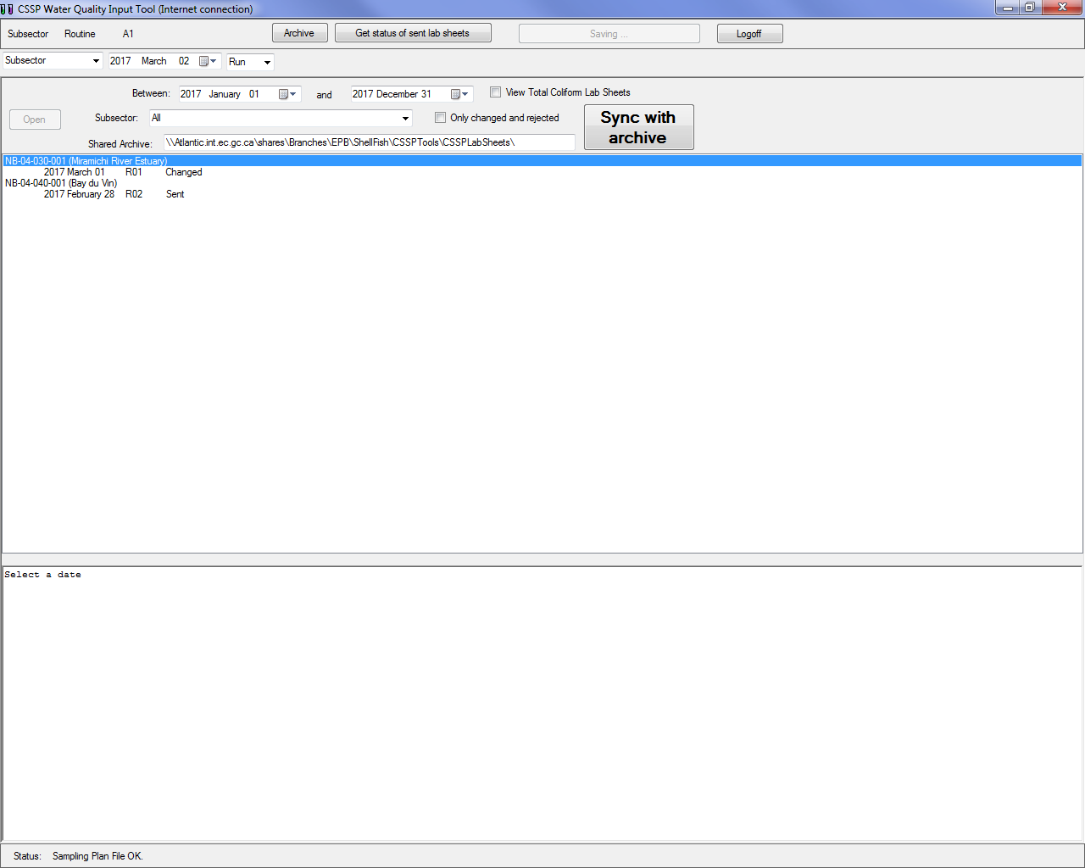

3.6 Description of first window

3.6.1 Row 1: Top row of options

- Subsector

  - Automatically selected at start – based on what was selected in the sampling plan.

- Routine
  - This is the sample type and will be automatically selected at the start based on what was selected in the sampling plan.

- A1
  - Automatically selected at start – based on what was selected in the sampling plan.

- View FC Form
  - Only activated once in a specific data sheet.
  - Is used to create the lab sheet (FC form) in word format with all the information entered via the application

- Fail
  - Used only when a specific run has failed and the data has been compromised or is unavailable (example: equipment failure, QC failure etc.)
  - If selected, a pop up box will prompt the user to choose whether or not they want to save the data as ‘total coliform’ or not. If the user selects yes, then the data sheet will be saved under a subdirectory in the year folder of that specific sampling plan. This is necessary in order to be able to create another data sheet for the same date/subsector with the fecal coliform results after the positive tubes have been transferred and re-incubated.
  - This permits the users to keep a history of failed runs without sending the data to the server.
  - This function is only activated once in a specific data sheet
  - Selecting the ‘Fail’ button again will make the data sheet editable again.

- Archive
  - Will show all files (data sheets) archived on your computer.

- Get Status of Sent Lab Sheets
  - When connected to a server, this button will allow you to update the information next to the date of each data sheet (accepted, changed, sent, rejected or fail). This information is
taken off the CSSP Web tools depending on what action (if any) the supervisor has taken at the approval stage.
  - Users should click on this button before starting to work on any lab sheet.

- Send to server/Already saved on server
  - Will indicate if user needs to upload new data to the server (CSSP webtools). It also serves as a status bar for when data is being saved (every 5 secs after you’ve made a change).
  - This function is only activated once in a specific data sheet.
  - Can only send a data sheet to the server once the lab supervisor has approved a completed data sheet
  - If you try to edit data once it has already been sent to the server for acceptance, a pop up will open asking the user if they are sure. This prevents accidental editing of data sheets that are either accepted or in the process of being accepted and also gives a reminder to the user to resend the data sheet to the server and sync with the archive once they have finished editing the data.

- Logoff
  - Would be used to logoff and protect the app.
  - Will have to reselect the sampling plan file and enter code.

3.6.2 Row 2: Second row of options

- Drop down selection of subsectors or municipalities (future)
  - List will contain all subsectors found in the sampling plan.

- Date selector
  - Use to select the date of the collected sample.
  - If the combination of subsector and date of collected sample have not been created yet, then the ‘create file’ button will appear next to the date.
  - If it has already been created it will automatically load the file and show you the data input screen. If you select (click once)

a data sheet that has already been created from the file listing section, the file location on your computer and name currently being used to store the information will appear.

- Run selector
  - Allows you to input data for multiple runs in one day for a same subsector.
  - Will default to one.

- Create File
  - Use to create a file with the subsector and date in its name.
  - The create file button will not be visible if the file already exist on your system.

3.6.3 Row 3, 4 & 5: File viewing section

- Drop down ‘Between Dates’
  - Filters data by selected dates.

- View Total Coliform Lab Sheets
  - This checkbox will filter failed lab sheets that were identified as total coliform data. This enables users to keep a record of original results in the instance of a circulator failure.

- Open button
  - Will be disabled if no file is selected.
  - Is used to load the selected file for editing.
  - Double clicking on a date will also load the file for editing.

- Drop down (subsector)
  - Filters data by subsector.

- Only changed and rejected
  - This checkbox filters the lab sheets so only the lab sheets that are incomplete are showing in the list.

- Shared Archive
  - This tells you the location where the data sheets and sampling plan get backed up to on the server (shellfish drive) when you press the ‘SYNC’ button next to the path name.
  - Will always default to that location on the shared drive.
  - Can change the path to create backup on a different folder or USB key if desired.

- Synch With Archive
  - When connected to a server, will send (sync) all the lab sheets and sampling plan on your computer to the path location selected (only sheets associated with the current
sampling plan that is loaded). It will also copy over any lab sheets from the server if there are any that are more recent then the ones on your local drive.

  - Should be clicked before starting to work/edit lab sheets so to make sure you are working on the most current lab sheets and should also be clicked before logging off of the input tool to ensure other users can access all the lab sheets you have created/edited.

3.6.4 Row 5: File listing

- Will list all the files (filtered or not) found on your computers CSSP lab sheets directory that correspond to the sampling plan you’ve uploaded in the input tool.

      - Files are ordered by subsectors and dates.

      - Selecting a file will enable the ‘Open File’ button on the 4th.

      - The R01, R02, etc. values indicate if this is the first run or second for that subsector on that date (will be R01 in most cases).

      - Files that have been sent to the server but not yet accepted or rejected by a biologist will have the word ‘Sent’ next to the date.
Files that have not been sent to the server since the last changes were made will have the word ‘Changed’ next to the date. Files that

have been sent to the server and accepted by a biologist will have the word ‘accepted’ next to the date. Files that have been sent to the server and rejected by a biologist will have the word ‘Rejected’ next to the date (in this case, consult with a biologist or supervisor for additional instructions). Lastly, files that have been started but failed for whatever reason will have the word ‘Fail’ next to them. These files cannot be sent to the server.

Selecting the ‘Get Status of Sent Lab Sheets’ button on the first row will update this information

3.6.5 Row 6: Text/data of selected file

- Will show textually all the parameters entered for the subsector and date selected. This serves as the log for each data sheet. Every time someone logs into the input tool using their initials and code and makes any

changes to a data sheet, the log will have a time and date stamp along with the initials of the person who made changes. The new information inputted will be next to the time stamp.

- These text files contain the exact information that will be sent to the server and used to create the word document version of the FC form.

3.6.6 Row 7: Status bar

- Used to guide and help the user

- Errors are shown on the status bar

- Help information is shown here as well

- ‘Modified’ will show every time something changes

- 5 seconds after the information is changed, it will be saved and ‘Modified’ will change to ‘Saved’

3.7 Description of second window- Full version with lab QA/QC

Once a file is created or a pre-existing file is loaded for editing you will see the screen below (page 8) if you are working with the full QA/QC version of input tool (for light version, see section 3.8).

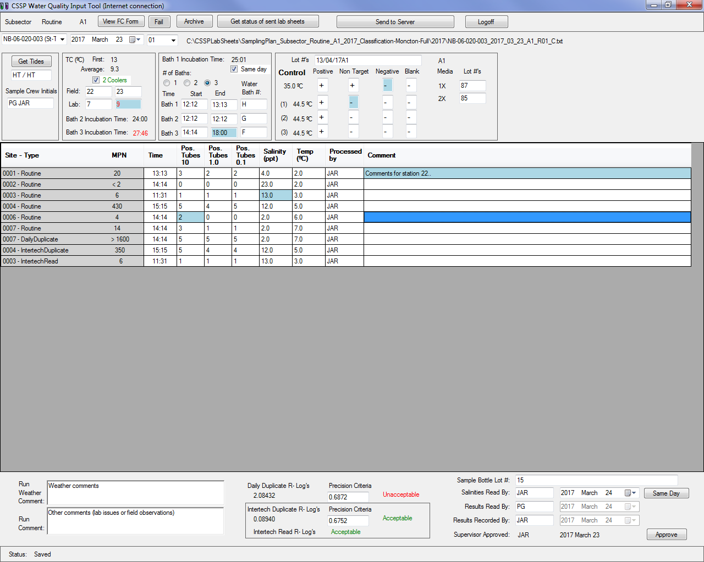

3.7.1 Row 1: Top row of options

- Same as above (3.6.1)
- Note: Clicking on the Archive Button will take you back to the previous screen
- Button (View FC Form)

- Will not be visible if no file is selected
  - Is used to create the lab sheet (FC form) in word format with all the information entered via the application

3.7.2 Row 2: Second row of options

- Same as above (3.6.2)

3.7.3 Row 3: Input part 1(Note: every time you leave a field/box, a log entry will be made that can be viewed in archive mode)

- Tide Start and End
  - If there is an internet connection, will be automatically generated using the time of first and last samples once user clicks ‘get tides’. The ‘get tide’ button will not be available unless there is at least one time data entered in the data fields bellow. You can override the value inputted by the ‘get tides’ button by double clicking in the box. You must input tides using a specific format (ex: HR / HR). If you make an error, it will be displayed in red and the status bar at the bottom will give you all the allowable letters.

- Sample Crew Initials
  - 2 or 3 letters per individual
  - Will be automatically uppercase when you leave the input box

- TC Field
  - Enter up to 4 digits. Use only periods ‘.’ and not commas ‘,’ (ex: 23.2)
  - If you had two coolers with samples, use the ‘2 coolers’ check box and input the second set of temperatures
  - Press tab or enter to move to next input box
  - Pressing ctr+enter will move to the previous input box

- TC Lab
  - Enter up to 4 digits. Use only periods ‘.’ and not commas ‘,’ (ex: 5.2)
  - Press tab or enter to move to next input box
  - Pressing ctr + enter will move to the previous input box

  - If TC Lab is ≥ 8.6 it will be red (flag for supervisor)
  - Application will automatically calculate average temperature and TC of first samples

- Incubation Same day check box
  - Will automatically be selected

  - If unselected, a pop up box will prompt the user to get supervisor approval and insert a comment in the ‘run comment’ as to who provided the approval.
  - If unselected, this indicate that the samples were processed the next day after sampling and will create a flag at the biologist level once the data is sent to the server.
  - If unselected, the ‘results read by’ and ‘results recorded by’ dates will automatically be changed to 48hrs after sampling date.

      - # of Baths
        - Select the number of baths used to incubate all the samples.
        - If you select 2 or 3, addition lines for ‘Incubation start time, incubation end time, water bath # and controls at 44.5oC) will appear.
        - Because of space restriction, ‘Bath 1 incubation Time’ and Bath 2 and 3 incubation time’ calculation (total incubation time) were separated.

- Incubation Start Time
  - You will need to enter time with only 4 numbers (ex: 0923 for 9:23 AM, 1324 for 1:24 PM)
  - After 4 correct numbers you will be moved to next input box
  - If there is an error the text will be red

- Incubation End Time
  - Same as Incubation Start Time
  - Once this box is filled, the total incubation time will be displayed on top of the start time. If it exceeds the 24 +/- 2 hrs incubation period, the time will be displayed in red

- Water Bath #
  - Can enter anything
  - Press tab or enter to move to next input box

  - Pressing ctr+enter will move to the previous input box

- Control Lot #’s
  - Anything is ok with a limit of characters

- Control 35ºC and 44.5ºC (Positive, Non-target, Negative)
  - Only one character allowed (+ or -) Non-target ‘N’ is allowed for labs not using a non-target control

  - Will automatically move to the next input box if ‘+’, ‘-‘ or ‘N’ was entered
  - Anything other than ‘+’,‘-‘ or ‘N’ will be red
  - Not having the right symbol (‘+’ or ‘-“) in the proper box will be shown in red

- Blank
  - Allowable (+ or -)
  - Will be automatically converted to uppercase
  - Anything other than ‘-’ will be in red
  - Can be left blank at 44.5ºC if not applicable for your lab

- Media Lot #
  - Anything is ok as long as 1X and 2X lot numbers are not the same

3.7.4 Row 4: Input part 2- field data and lab results

- Grid with site number, Type, MPN, Time, Pos. Tubes 10, Pos. Tubes 1.0, Pos. Tubes 0.1, Salinity, Temperature, Processed by and Comment

- Grayed box are read only

- To move around in the grid you can use Arrow keys, Tab or Enter

- While entering data use ‘Enter’ to accept input and move down

- While entering data use Arrow or Tab to move to next horizontal cell

- You can also use Shift+Tab to move to previous horizontal cell

- Site is read only and is set by EC staff using the CSSPWebTools. It represents the sampling station.

- Sample Type is read only and is set by EC staff using the CSSPWebTools

- MPN is automatically entered after all 3 tubes are entered with acceptable values. It will show ‘error’ if combination of tubes is not allowed (un-usual tube combination).

- Time should be entered using only 4 digits (ex: 1323 for 1:23 PM, 0945 for 9:45 AM). Time will be red if error in input occurred

- Tubes allowable values are (0, 1, 2, 3, 4 and 5). Tubes will be red if error in input occurred.

- If a sampling station was sampled multiple times in one day (infrastructure sampling for instance), pressing on F5 after first clicking on the appropriate sample will allow the user to add another line for the additional samples. *It is important here that users do NOT change the sampling time of these samples once they have finished inputting the data. Pressing F5 again will allow the user to delete that sample.

- Salinity will accept any values between 0.0 to 36.0

- Temperature will accept any values between 0.0 to 36.0

- Processed by should contain the initials of the person who processed the sample. Will automatically use the initials of the cell above it (if there is one) once you move out of the cell.

- Comment: use to hold comments related to the site (sampling station) during the field run or Lab QC information for that sample.

- You can select a different duplicate by clicking the desired sites box (in gray) and pressing F2. A separate box will open and ask you if you want to create a new duplicate. The input tool will remember the last duplicate used for a particular subsector and will use it by default on the next data sheet. Sampling time, salinity, temperature and processed by initials for daily duplicated will automatically be filled in with the original sample data.

- If you have a monthly InterTech duplicate and/or an InterTech reading test to enter, click on the appropriate sampling station and then press F3 to create an additional line for the InterTech duplicate OR F4 to create an additional line for the InterTech reading. If you made a mistake and need to delete this additional line, select the original sampling station again and repress on F3 or F4 and a prompt will ask you if you would like to delete this particular InterTech dup/reading. Sampling time, salinity and temperature for interTech duplicates and InterTech reading test will automatically be filled in with the original sample data.

3.7.5 Row 5: Input part 3

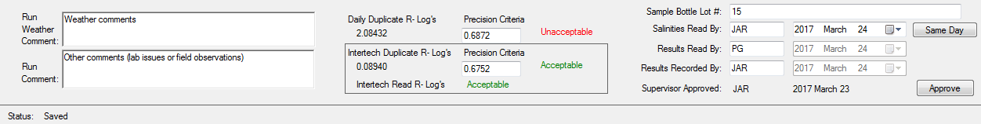

- Run Weather Comment
  - Anything related to the weather during sampling run

- Run Comment
  - Any relevant observation during the sampling run or during the processing of the samples at the lab

- Daily Duplicate calculation and Intertech Duplicate/Read
        - The precision criteria is lab specific (entered in sampling plan) and will remember last number imputed
        - R-Log’s are the difference between the logs of the sample and the duplicate
        - Next to the Precision Criteria, you will either see Acceptable (green) if the R-Log’s value is less than the Precision Criteria or Unacceptable (red) otherwise.

- Sample Bottle Lot #
  - Any text representing sample bottle lot #

- Salinities Read by (initials and date)
  - Initials, 2 or 3 letters will be automatically converted to uppercase
  - Date salinities were read (will by default be 24 hrs after sampling date).
  - Can be changed to any date or you can use the button to use the same date as the sampling date.

- Results Read by (initials and date)
  - Initials: 2 or 3 letters. Will be automatically converted to uppercase
  - Date: date results were read. Will by default be date 24hrs after sampling date or 48hrs after sampling date if the ‘same day’ check box was unclicked. Cannot be changed

- Results Recorded by (initials and date)
  - Initials: 2 or 3 letters. Will be automatically converted to uppercase

  - Date: date results were recorded on the input tool. Will by default be the same as ‘Results read by’ date. Cannot be changed.

- Supervisor Approval
  - No input necessary for summer staff
  - Allows lab supervisor to approve the data sheet (using their approval code) and the approve button
  - Will automatically input user initials and date
  - Once clicked, will activate the ‘send to server’ button

3.8 Description of second window- Light version (no lab QA/QC)

Once a file is created or a pre-existing file is loaded for editing you will see the screen below (page 15) if you are working with the light version (no lab QA/QC) of input tool (for full version, see section 3.7).

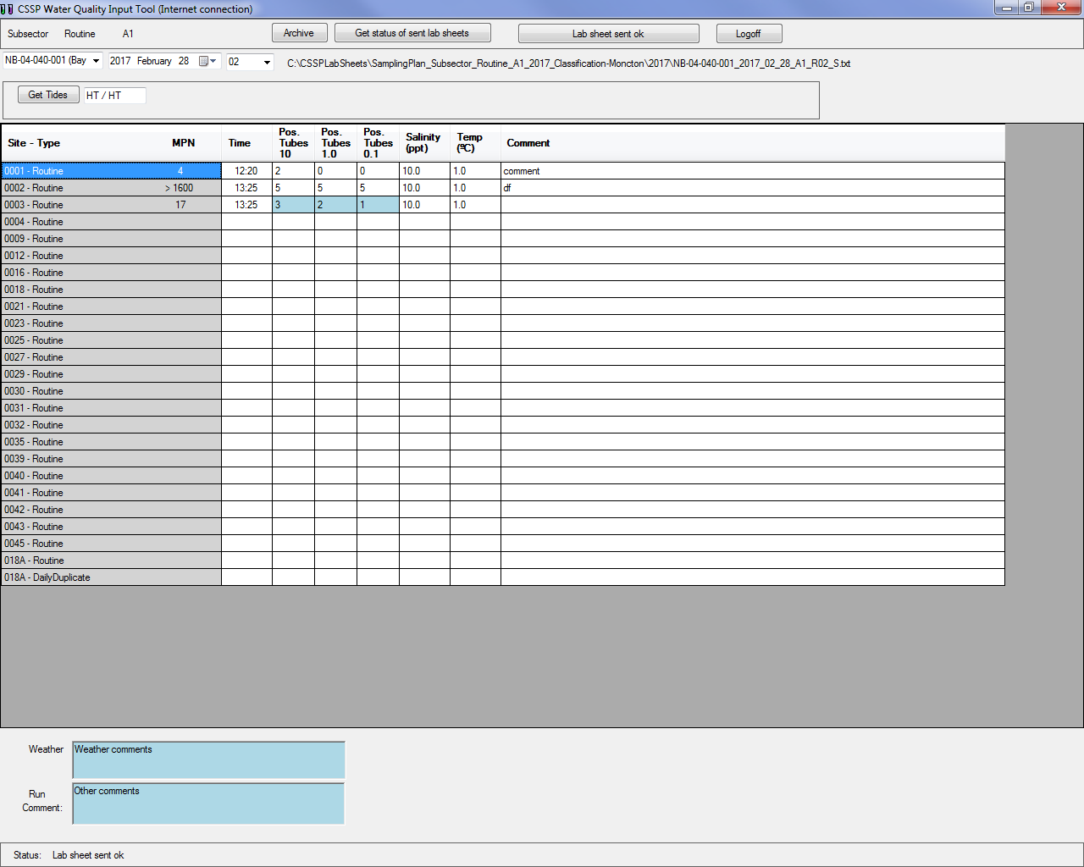

3.8.1 Row 1: Top row of options

- Same as above (3.7.1)

3.8.2 Row 2: Second row of options

- Same as above (3.6.2)

3.8.3 Row 3: Tide Start and End

- If there is an internet connection, will be automatically generated using the time of first and last samples once user clicks ‘get tides’. The ‘get tide’ button will not be available unless there is at least one time data entered in the data fields bellow. You can override the

value inputted by the ‘get tides’ button by double clicking in the box. You must input tides using a specific format (ex: HR / HR). If you make an error, it will be displayed in red and the status bar at the bottom will give you all the allowable letters.

3.8.4 Row 4: Input - field data and lab results

- Grid with site number, Type, MPN, Time, Pos. Tubes 10, Pos. Tubes 1.0, Pos. Tubes 0.1, Salinity, Temperature, and Comment

- Grayed box are read only

- To move around in the grid you can use Arrow keys, Tab or Enter

- While entering data use Enter to accept input and move down

- While entering data use Arrow or Tab to move to next horizontal cell

- You can also use Shift+Tab to move to previous horizontal cell

- Site is read only and is set by EC staff using the CSSPWebTools. It represents the sampling station.

- Sample Type is read only and is set by EC staff using the CSSPWebTools

- MPN is automatically entered after all 3 tubes are entered with acceptable values. It will show ‘error’ if combination of tubes is not allowed (un-usual tube combination).

- Time should be entered using only 4 digits (ex: 1323 for 1:23 PM, 0945 for 9:45 AM). Time will be red if error in input occurred

- Tubes allowable values are (0, 1, 2, 3, 4 and 5). Tubes will be red if error in input occurred.

- If a sampling station was sampled multiple times in one day (infrastructure sampling for instance), pressing on F5 after first clicking on the appropriate sample will allow the user to add another line for the additional samples. *It is important here that users do NOT change the sampling time of these samples once they have finished inputting the data. Pressing F5 again will allow the user to delete that sample.

- Salinity will accept any values between 0.0 to 36.0

- Temperature will accept any values between 0.0 to 36.0

- Comment: use to hold comments related to the site (sampling station) during the field run or Lab QC information for that sample.

- You can select a different duplicate by clicking the desired sites box (in gray) and pressing F2. A separate box will open and ask you if you want to create a new duplicate. The input tool will remember the
last duplicate used for a particular subsector and will use it by default on the next data sheet. Sampling time, salinity and temperature for daily duplicated will automatically be filled in with the original sample data.

- If you have a monthly InterTech duplicate to enter, click on the appropriate sampling station and then press F3 to create an additional line for the InterTech duplicate OR F4 to create an additional line for the InterTech reading. If you made a mistake and need to delete this additional line, select the original sampling station again and repress on F3 or F4 and a prompt will ask you if you would like to delete this particular InterTech dup/reading. Sampling time, salinity and temperature for interTech duplicates and InterTech reading test will automatically be filled in with the original sample data.

*Note: Daily duplicate and intertech duplicate are entered in the ‘light version’ of the input tool in order to have their MPN values automatically used instead of the original sample if the duplicates are of a higher MPN value.

3.8.5 Row 5: Comments

- Weather
  - Anything related to the weather during sampling run

- Run comment
  - Any relevant observation during the sampling run or during the processing of the samples at the lab

3.9 Sync with Archive overwrite window

To prevent two users from editing the same data sheet at the same time from two different computers and overwriting each other’s data, a new feature has been put in place.

If you either try to send to server a data sheet for acceptance or sync with archive and there is already a data sheet there with the same subsector and the same date, the input tool will open a new screen that shows the two data sets (see page 19). The different data will be highlighted in red and you will have to either copy this information (copy the ‘sender/red’ information over the ‘receiver’ information) over the old information (receiver) or not (skip). Pressing cancel will cancel the archive sync or ‘send to server’ process while pressing ‘skip’ will not copy over the sender data and go to the next data sheet that needs to be addressed. It is very important to verify the two data sheets to insure that no data is lost by overriding a previous version.

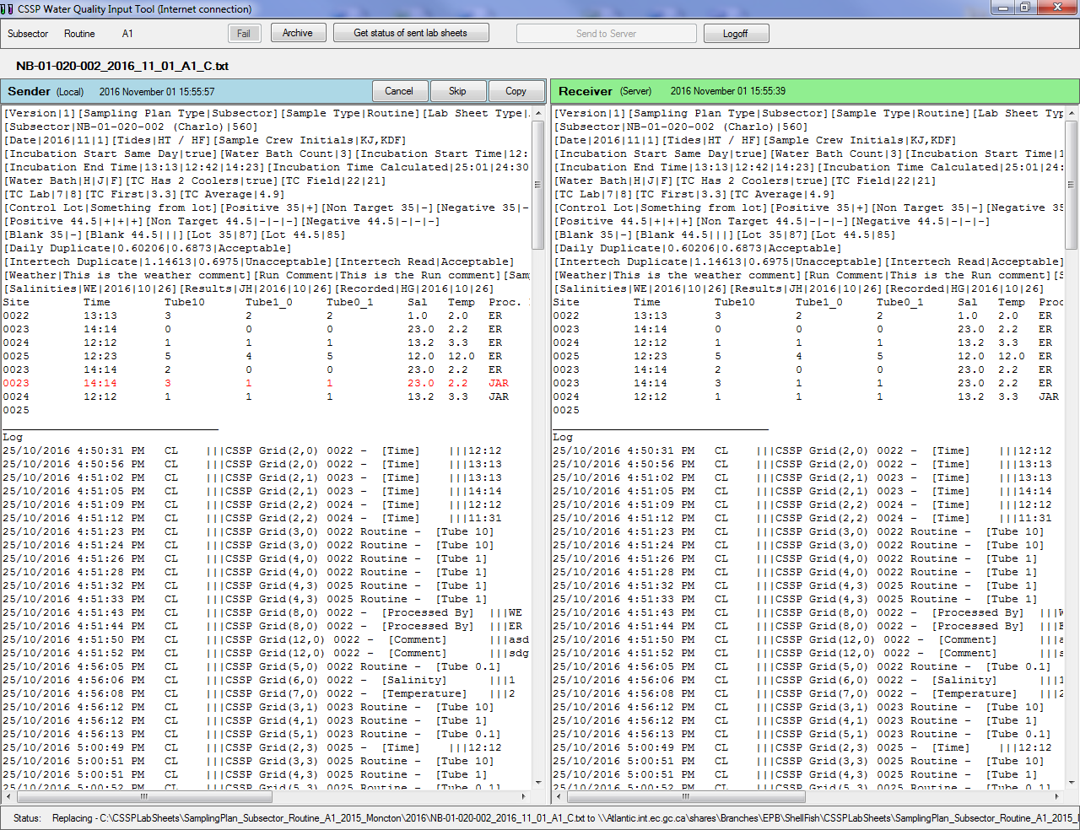

- MAINTENANCE/TROUBLESHOOTING

- If for whatever reason an error occurred while reading the sampling plan file, the status bar at the bottom of the application will indicate the line number and the error.

- If for some reason you need to delete or re-edit a data field, select the appropriate cell and press F2 or double click on the cell. If the sampling date is the cell you want to modify, pressing F2 will open a separate box that will allow you to change the date. If the date of the data set is changed, the old data with the old date will be stored in the ‘’not used’ folder under your CSSPlabsheets folder in case the wrong data set was modified. Whenever you make changes to a data sheet that was previously sent to the server, you need to re-send it to the server so it can be accepted or rejected by a biologist. The new sheet will override the previous one in the database. When you change data in any data field, the field will change to a blue background. This indicates to the user that the data has been changed and they can refer to the data log to see what the change was, when it was done and by whom.

- If you need to delete and entire data sheet/field run, you will need to go in your CSSPLabsheets folder under my document and find/delete it from your 2017 (or appropriate year) folder. You will also need to delete if from the Shellfish back up drive if you had previously synced your archive with the server. Deleting a data sheet from the my document CSSP folder will remove it from the input tool list but if it was already sent to the server, it will need to be deleted in the Web tools as well. See ‘Basis functionalities of the CSSP Web Tools’ for instructions on how to delete a data sheet from the data base. Check with a supervisor before deleting any data from the input tool. Changed cells will become blue to indicate that it was edited.

- If an unusual tube combination is entered in the input tool, an error message in red will appear instead of the MPN value. If a user tries to send this to the server, a pop up box will
ask if the user is certain. This will ensure that staff double checks for any typos before sending the information to the server. If the user is sure and sends the data to the server for biologist acceptance, the biologist will have a flag at the acceptance stage in the web tools. Biologist will either reject the data sheet and ask the lab staff to assign a value in the input tool as well as a comment with the original tube combination and resend to server OR biologist will accept the data sheet and no data for that sampling station on that date will be recorded in the database.

- If you need to add another sample of the same station number, select the station number and press on F5.

- For any additional troubleshooting help (errors or bugs), please contact Charles LeBlanc (Charles.leblanc@ec.gc.ca). For general questions, contact your local CSSP working group committee member.

